12 Hour Endurance Car Race

The Historic Racing Club and Taupo Classic Rally Club held the inaugural 12 Endurance Race for open class saloon cars at Hampton Downs Raceway on Saturday.

Taupo drivers, Rick Cooper, Deon Cooper and Mike Ashton in their Hyundai sponsored Ford GT won after an action filled race. Second home was a CEMAC sponsored BMW E30 of Hamilton drivers Ross Wilson, Martyn & Mathew Seddon. Third home was the Blenheim Toyota sponsored Toyota Corolla twin turbo of South Island competitors Craig & Scott McDermid and Patrick Heagney

The race started at 7.00 am on a clear day and continued in sunny conditions until the finish flag was presented at 7.00pm to the winning team after 501 laps of the 2.8km Hampton Downs Raceway.

The safety car was dispatched onto the course several times, allowing recovery vehicles to tow several competitors back to the pits for repairs. The most spectacular
incident was a fire in the Gulf Fuels sponsored Goodwin, Hooper, Simmons V8 Saker, which was just leaving the pits when it caught fire. The fire was extinguished quickly by an FIV team which confined the damage to wiring and an engine cover, however the damage meant that that was the end of their race.

An endurance race also relies on team work in the pits, as every 2 hours the cars need refueling and tyre changes. All teams had issues that caused delays in the pits, meaning the lead of the race changed several times during the 12 hour event.

Only 9 cars were classified as finishers.

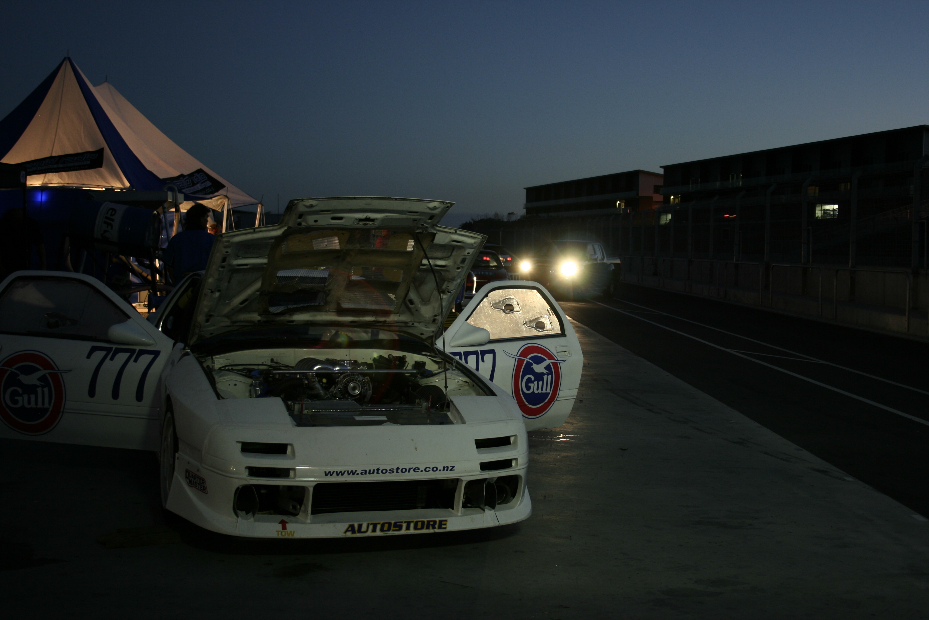
Alan Barnes – www.classicrally.org.nz

